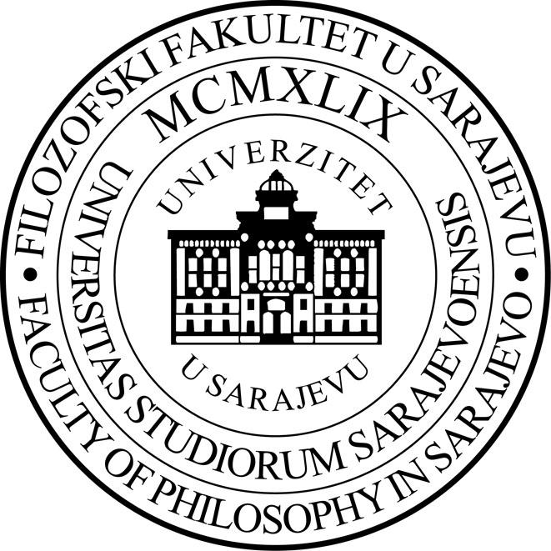

Centar za mirovno obrazovanje, Filozofski fakultet, Univerzitet u Sarajevu
forum ZFD BiH/Predstavništvo Forum Ziviler Friedensdienst e. V. u Bosni i Hercegovini

LJETNA ŠKOLA MIROVNE PEDAGOGIJE (14.6.2022.- 16.6.2022.)
Utorak  14.6.2022. | Srijeda  15.6.2022. | Četvrtak  16.6.2022.
16.00-18.00 Online | 16.00-19.00 Online | 10.00- 12.00 Filozofski fakultet u Sarajevu  16.00-18.00 Online
Otvorenje  Od mirovnog obrazovanja do mira u najširem smislu: Refleksije o izgradnji mira od individualne do društvene i institucionalne promjene | Uvodno obraćanje i diskusija u malim grupama: Iskustva nastavnika i studenata sa korištenjem metoda i strategija koje potiču diskusiju u razredu  Radionica  Strategije za poticanje demokratije i diskusije u razredu i školi  Refleksija u malim grupama: Integrisanje strategija za poticanje diskusije u nastavi | Međunarodni studentski panel  Istraživanja u oblasti izgradnje mira i mirovnog odgoja i obrazovanja  Filozofski fakultet u Sarajevu  Predavanje i diskusija  Promoviranje kulture mira kroz promišljanje o konceptu pravde  Refleksije i iskustva sa kolegija „ Koja je uloga vladavine zakona u zatvaranju mračnih poglavlja historije? Slučaj Bosne i Hercegovine“  Zatvaranje
Randall Puljek-Shank | Judy Pace | Nadia Sonneveld  Studenti:  Sara Troian, Francesca Anstey,  Azra Hodžić, Ernad Mahmić,  Dina Gusinac, Emina Džanko
Moderator:  Michele Parente | Moderators:  Larisa Kasumagić- Kafedžić  Emina Dedić Bukvić | Moderators:  Lejla Mulalić  Nadia Sonneveld  Larisa Kasumagić- Kafedžić
Predavači i moderatori:
Randall Puljek-Shank, Mirovna Akademija, Sarajevo
Judy Pace, Univerzitet San Francisco
Nadia Sonneveld, Univerzitet Leiden, Holandija
Michele Parente, forumZFD BiH
Lejla Mulalić, Filozofski fakultet u Sarajevu, Centar za mirovno obrazovanje
Emina Dedić Bukvić, Filozofski fakultet u Sarajevu, Centar za mirovno obrazovanje
Melisa Forić- Plasto, Filozofski fakultet u Sarajevu, Centar za mirovno obrazovanje
Larisa Kasumagić- Kafedžić, Filozofski fakultet u Sarajevu, Centar za mirovno obrazovanje

Peace Education Hub, Faculty of Philosophy, University of Sarajevo
forumZFD in BiH/ Representation of Forum Civil Peace Service in Bosnia and Herzegovina

PEACE PEDAGOGY SUMMER SCHOOL (June 14 – June 16, 2022.)
Tuesday  June 14, 2022 | Wednesday  June 15, 2022 | Thursday  June 16, 2022
16.00-18.00 Online | 16.00-19.00 Online | 10.00- 12.00 Faculty of Philosophy University of Sarajevo  16.00-18.00 Online
Opening  From Peace Education to Peace Writ Large: Reflections on Building from Individual to Social and Institutional Change | Introduction and discussion in small groups: Teachers’ and students’ experiences with discussion-based pedagogical approaches  Workshop  Democratic Discussion Pedagogies  Break  Reflection in break out rooms: Creating discussion-based lesson plans | International Student Panel  Research in peacebuilding and peace pedagogies in education  Faculty of Philosophy Sarajevo  Lecture and discussion  Promoting the Culture of Peace by Rethinking the Concept of Justice  Reflections on the course  Using the Rule of Law to Close Dark Chapters of History? The Case of Bosnia and Herzegovina  Closing
Randall Puljek-Shank | Judy Pace | Nadia Sonneveld  Students:  Sara Troian, Francesca Anstey,  Azra Hodžić, Ernad Mahmić,  Dina Gusinac, Emina Džanko
Moderator:  Michele Parente | Moderators:  Larisa Kasumagić- Kafedžić  Emina Dedić Bukvić | Moderators:  Lejla Mulalić  Nadia Sonneveld  Larisa Kasumagić- Kafedžić
Lecturers and moderators:
Randall Puljek-Shank, Peace Academy, Sarajevo
Judy Pace, University of San Francisco
Nadia Sonneveld, Leiden University, Netherlands
Michele Parente, forumZFD
Lejla Mulalić, Faculty of Philosophy Sarajevo, PEH
Emina Dedić Bukvić, Faculty of Philosophy Sarajevo, PEH
Melisa Forić- Plasto, Faculty of Philosophy Sarajevo, PEH
Larisa Kasumagić- Kafedžić, Faculty of Philosophy Sarajevo, PEH
Biographies and Workshop/Lecture Abstracts

Tuesday, June 14, 2022 (16-18), Online

Randall Puljek- Shank: From Peace Education to Peace Writ Large: Reflections on building from individual to social and institutional change

My own positionality as a peacebuilding pracademic, political scientist, bostranac. Peace Education in BiH- three case studies which were selected because they were sustained over at least 5 years with varying approaches to institutionalization. EFP worked with international organizations and ministries, AVP worked with teachers as individuals but not with schools as institutions, while the Nansen work focuses on extra-curricular activities in schools.

Dr. Randall Puljek-Shank has more than 20 years of experience in peacebuilding in the Western Balkans in programme design, implementation, training, evaluation, and research. He worked with the NGO Mennonite Central Committee from 2002 to 2012, supporting local organisations focused on strategic peacebuilding, inter-religious action, and trauma healing. Randall holds a PhD in Political Science from the Radboud University Nijmegen. His doctoral research deepened his interest in the intersection of civil society and politics of ethnically divided societies, and chapters of his dissertation appeared in the journals Cooperation and Conflict, and Voluntas. He has taught undergraduate political science, social movements and capacity building, programme planning, monitoring, and evaluation, and peacebuilding theory. His recent work includes a programme evaluation of 20 years of support for civic education programmes in Bosnian schools. He also designed and facilitated five exchanges for selected government and NGO participants from Ukraine to learn from the experience of Bosnian practitioners, and he led training in Ukraine on the “Do No Harm” approach.

Wednesday, June 15, 2022 (16-19), Online
Judy Pace: Democratic Discussion Pedagogies Workshop

Classroom discussion is central to democratic education; however, it does not often occur. This workshop will begin to build a foundation for the practice of democratic classroom discussion. It will address the following goals through research-based guidance and examples:
- Understand what democratic classroom discussion involves and why it is so important,
- Understand how to prepare for high quality classroom discussion,
- Become acquainted with different approaches to democratic discussion.

Dr. Judith Pace is Professor of Education at the University of San Francisco (https://www.usfca.edu/faculty/judith-pace).
Her research investigates classroom curriculum and teaching in the socio-political, cultural, and institutional contexts of schooling and focuses on democratic education. Her latest book is Hard Questions: Learning to Teach Controversial Issues (Rowman & Littlefield, 2021) and her website is at https://teachingcontroversies.com/.
Thursday, June 16, 2022 (10-12), Faculty of Philosophy
International Student Panel:
Sara Troian, Francesca Anstey, Azra Hodžić, Ernad Mahmić, Dina Gusinac, Emina Džanko

Sara Troian, MA student Law and Society, Van Vollenhoven Institute for Law, Governance and Society, Leiden University
For her MA thesis Sara investigates different narratives about the Bosnian War from the perspective of young people born after 1995 belonging to each recognised ethnic group (Bosniaks, Croats and Serbs) with the aim to assess the status of reconciliation.

Francesca Anstey, MA student Law and Society, Van Vollenhoven Institute for Law, Governance and Society, Leiden University
For her MA thesis, Francesca analyses Bosniak women’s roles, norms, and customs regarding death and funeral procedures. She asks whether these have altered after the war in Bosnia and Herzegovina, and how we can explain this?

Azra Hodžić, University of Sarajevo, Faculty of Philosophy, Department of Pedagogy
This presentation will focus on the MA thesis: The Specific Methods of Peace Education. During her presentation, she will explain the most important terms which are: peace, peacebuilding, and peace education (formal and non-formal). She will illustrate specific methods used in peace education by framing them into the research results. She will describe her own experiences with peace education that she has gained by attending seminars organized by various NGOs. She will also discuss the future of peace education in Bosnia and Herzegovina.
Azra Hodžić is a fifth-year student of Pedagogy at the University of Sarajevo. Besides being a student she is an active volunteer. Currently, she is volunteering in the Youth for Peace organization. Gaining experiences through studying and volunteering she has developed interest in peacebuilding. Her main focus is studying, researching, and advancing further into the field of peace education.

Ernad Mahmić, University of Sarajevo, Faculty of Philosophy, Department of English
This presentation is based on his MA thesis: Comparative Study of Critical and Peace Pedagogy in Creating Socially Responsible Classrooms. It explores the importance of peace education and critical pedagogy in post-conflict education, comparing approaches within Bosnia and Herzegovina and in other countries. The presentation will deal with the willingness and ability of Bosnian EFL teachers to implement peace education into their classrooms, their main obstacles, as well as the techniques and approaches which have been proven to work best locally as well as abroad.
Ernad Mahmić is a fifth-year student of English Language and Literature, Teacher Education Program, at the University of Sarajevo. From a young age he has shown an interest in literature as well as education, and has recently become interested in matters of spirituality and peacebuilding.
Dina Gusinac & Emina Džanko, University of Sarajevo, Faculty of Philosophy, Department of History
This presentation For a more equal society: Tristan and Truth - narratives used for gaining women's rights is based on a seminar research on different approaches to gender inclusion in societies with diverse social and political contexts. The presentation will address topics important for learning about peacebuilding and equality in two different socio-political discourses using historical facts about the lives of two very impressive historical figures. The lives of Flora Tristan and Sojourner Truth were significant in building a narrative that helped women gain women’s rights.
Dina Gusinac is a fourth-year student of History at the University of Sarajevo. Since high school she has attended human rights courses with an emphasis on women's rights. Through her history studies, she learned that peace is important for a society of cooperation, tolerance and prosperity, and this has influenced her more in dealing with human rights topics and peacebuilding. Her main focus is women’s rights, women’s history and education for peacebuilding.
Emina Džanko is a fourth-year student of History, Teacher Education Program, at the University of Sarajevo. She is currently volunteering at Erasmus Student Network Sarajevo where she gained experience in working with other foreign students and people of different backgrounds and interests. Her interest is mainly in the field of Modern History, with main focus on social, cultural and scientific development of society. She is passionate about learning new methods in the field of education, which can help young people understand the importance of history. She learned that by using historical facts people can build different narratives and that helped her realize the importance of using them for good purposes, and one of them is education.

Thursday, June 16, 2022 (16-18), Online
Nadia Sonneveld: Promoting the Culture of Peace by Rethinking the Concept of Justice
This session focuses on the Honours Course “Using the Rule of Law to Close Dark Chapters of History? The Case of Bosnia and Herzegovina.” The (online) course was given for the first time in 2021 and included students and speakers from Leiden University and the University of Sarajevo. We specifically focused on the meaning of justice and rule of law in a post-conflict society. What is justice? What is rule of law? And, who decides this? Is it enough to pass legal judgements or does justice require more? We asked students to (1) reflect critically on their own understandings of justice and rule of law, in general, and in the specific context of Bosnia and Herzegovina, and (2) to compare their own visions to those of war and genocide survivors. To this end, meetings and interviews with Bosnian survivors in The Netherlands and Bosnia were arranged and filmed by Bosnian filmmaker Ado Hasanović. The materials are currently being reworked into a short documentary. (Parts of) the documentary will be screened during the session.
Dr. Nadia Sonneveld works as an associate professor at the Van Vollenhoven Institute for Law, Governance and Society, Leiden Law School. She has an academic background in Anthropology, Arabic, and Law. In her research she focuses on gender, law and migration in the Middle East and North Africa. A few years ago, she started research on the subject of law and justice in Bosnia and Herzegovina.

