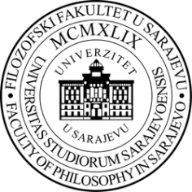

Application Form
International Summer School
„OutBreak! – Social Trauma in Changing Societies (STICS)“
20.-27.06.2021, University of Sarajevo/Online
(alternative dates: 20.-27.09.2021)

Please fill in and sign this application form. Then send it together with all further applications documents, preferably in one single PDF file, via e-mail to sticsbih@gmail.com

Personal Data
Name: |  |  |  | First Name: |  |  |  |  | Sex: | m f d
Citizenship: |  |  |  |  |  |  | Date of Birth:
E-Mail:
Current Studies
Study Program:
Study Cycle: |  |  | MA PHD |  |  |  | Completed Study Years:
Please note that bachelor students are not eligible for application! (Exception: Bachelor Students from countries with a 4-year Bachelor and 1-year Master Program can participate, if they confirm to study in their 4th year)
Application Details
Are you applying to participate in presence in Sarajevo  (= ambassador student) or as an online participant or  would both options be suitable for you? |  |  |  |  |  |  |  | only participation in presence..  only online participation..  participation either online or in presence..
In case the summer school has to be postponed to  20.-27.09.2021, would these dates be suitable for you as well? |  |  |  |  |  |  |  | yes no
(Place, Date) |  |  |  |  | (Signature)

